# Project Design and Proposal

## **Connect Smith**

**Business Functions**

* Connect Smith is a database management system developed for the Robert H Smith School of Business MSIS course to aid current students to obtain alumni information. The database is required to keep track of all the details of the MSIS alumni.
* Each alumnus is described by a uID, First Name, Last Name, date of birth (DOB), City and batch.
* The details of the companies they worked for and are currently working in must be maintained.
* Each alumnus has the start date, end date and location of the company for each different company he/she has worked.
* The details of donations made by the alumni for the projects undertaken by current students is maintained.
* The of the current and past project undertaken by the students and professors is maintained.
* The details of past and future events and alumni attendance for those events is maintained in the database.
* The skills possessed by the alumnus must be maintained in the database.
* The details certifications done by the alumnus are must be maintained in the database.

**Mission Statement**

Connect Smith aims to provide comprehensive and high-quality information services that enables students of the Robert H. Smith School of Business to access current alumni information and get a better insight into the real world and industry dynamics.

**Mission Objectives**

●To have a centralized management to maintain complete alumni information.

●Track all research projects sponsored by the alumni

●Track the future and past events attended by the alumni.

●Provide a comprehensive repository that enlists the current and past work details of the alumni

●Showcase the certifications and accolades earned by the alumnus

**Source**

Robert H.Smith School’s Department of Alumni Relations(DAR).

**Business Transactions**

* What are the First Name, Last Name, Email, Batch, Work Positions and Company Name for Alumni who graduated in a given year?
* What are the First Name, Last Name, Email,Batch, Work Positions and Company Name for the Alumni who are working for a given company?
* What are the First Name, Last Name, Email, Batch Work Positions, Company Name who have graduated in a given year and are working in a given company?
* What are the First Name, Last Name, Email, Work Position, Batch, Company Name who have graduated in a given year and are working in a given position?
* What are the First Name, Last Name, Email, Work Position, Batch, Company Name who are working in a given company and are working in a given position at that company?
* What are the First Name, Last Name, Email, Batch, Work Position and Company Name for Alumni who graduated in a given year and are working in a given company at a given position?
* What are the First Name, Last Name, Email of the Alumni who have attended past events?
* What are the First Name, Last Name, Email of the Alumni, Event Name who are going to attend future events?
* What are the First Name, Last Name, Email, Gender of the Alumni, Project Details and Donation Amount for Alumni who have donated for a given project?
* What are the certification names and the count of alumni who have done the that particular certification?
* What are the alumni details who graduated in 2014 and are working as a Jr Data Analyst in Deloitte LLP?
* What are the First Name, Last Name, Gender, Email of Alumni who have donated for the Project ‘Smith Alumni Management’?

**ER Diagram**

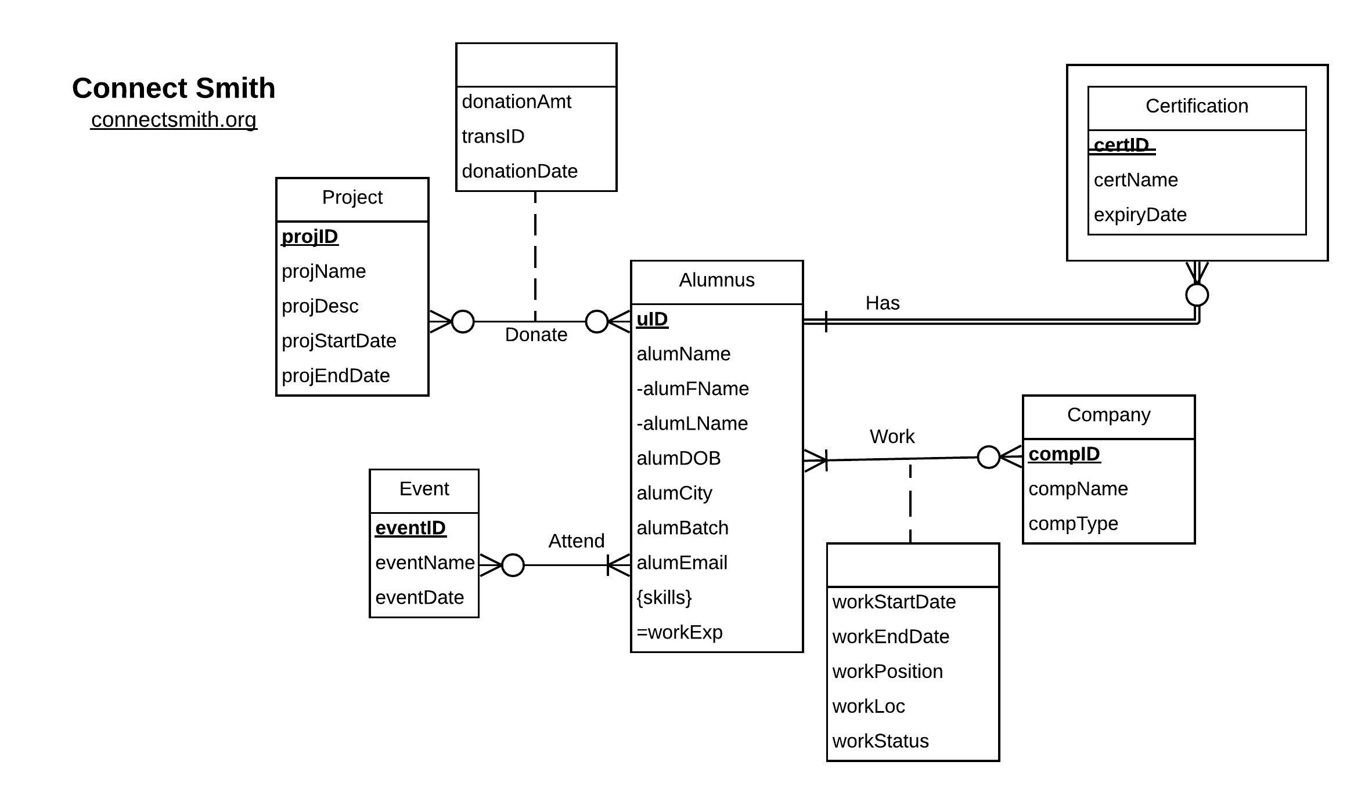

**ER Schema**

**Entities, Attributes and Primary Keys**

Alumnus(**uID**, alumFName, alumLName, alumDOB, alumCity, alumBatch, alumEmail)

Company(**compID,** compName, compType)

Event(**eventID,** eventName, eventDate)

Project(**projID**, projName, projDesc, projStartDate, projEndDate)

Certification(**certID**, certName, expiryDate)

**Relationships, Attributes, Degrees, Participating Entities and Constraints:**

Work(workStartDate, workEndDate, workPosition, workLoc, workStatus): binary relationship

1 Alumnus to 0 or more companies

1 Company to 1 or more alumnus

Donate(donationAmt, transID, donationDate): binary relationship

1 Alumnus to 0 or more Projects

1 Project to 0 or more Alumnus

Attend: binary relationship

1 Alumnus to 0 or more Events

1 Event to 1 or more Alumnus

Has: binary relationship

1 Alumnus to 0 or more Certifications

1 Certification to 1 Alumnus

**Relational Schema**

Alumnus (**uID**, alumFName, alumLName, alumDOB, alumCity, alumBatch, alumEmail)

Company (**compID**, compName, compType)

Event (**eventID**, eventName, eventDate)

Project **(projID**, projName, projDesc, projStartDate, projEndDate)

Certification (**certID, *uID***, certName, expiryDate)

Work (***uID***, ***compID***, workStartDate, workEndDate, workPosition, workLoc, workStatus)

Donate (***uID***, ***projID***, donationAmt, transID, donationDate)

EventAttendance (***uID***, ***eventID***)

AlumnusSkill (***uID***, skill)

**Functional Dependencies**

uID-> alumFName, alumLName, alumDOB, alumCity, alumBatch, alumEmail  
projID->projName, projDesc, projStartDate, projEndDate   
compID ->compName, compType  
eventID ->eventName, eventDate

uID, compID->workStartDate, workEndDate, workPosition, workLoc, workStatus

eventID, uID ->

uID, skill ->

projID, uID -> donationAmt, transID, donationDate

certID, uID -> certName, expiryDate

**Relations in 3NF**

Alumni (**uID**, alumFName, alumLName, alumDOB, alumCity, alumBatch, alumEmail) =3NF

Project (**projID**, projName, projDesc, projStartDate, projEndDate) =3NF

Company (**compID**, compName, compType) =3NF

Event (**eventID**, eventName, eventDate) =3NF

EventsAttendance (***uID***, ***eventID***) =3NF

Donate (***projID***, ***uID, transID***, donationAmount) =3NF

Work (***uID***, ***compID***, workStartDate, workEndDate, workPosition, workLoc) =3NF

AlumnusSkill (***uID***, skill) = 3NF

**Business Rules**

[R1] When a record of an alumnus is deleted from the database, his/her corresponding work details should be deleted accordingly.

[R2] When an alumnus identifier is updated in the database, the corresponding work information of the alumnus must be updated accordingly.

[R3] A company cannot be deleted from the database if an alumnus is currently working in the company.

[R4] When a company identifier is updated in the database, the corresponding work information should be updated accordingly.

[R5] A record of an alumnus who made a donation for a project cannot be deleted from the database.

[R6] When an alumnus identifier is updated in the database, the corresponding donation information must be updated accordingly.

[R7] If a project has donations made to it, the corresponding project record cannot be deleted from the database.

[R8] When a project identifier is updated in the database, the corresponding donation information must be updated accordingly.

[R9] When the details of an alumnus is deleted from the database, the corresponding details of events attended by that alumni must be deleted.

[R10] When an alumnus identifier is modified, the details of the events attended by the alumnus must be modified accordingly.

[R11] When an event record is deleted from the database the corresponding event attendance details must be deleted from the database.

[R12] When an event identifier is updated in the database the corresponding event attendance details must be updated accordingly.

[R13] When an alumnus record is deleted from the database the corresponding certificate details of the alumni must be deleted.

[R14] When an alumnus identifier is updated in the database the corresponding certificate details of the alumni must be updated.

[R15] When a record of an alumnus is deleted from the database the corresponding skill details of that alumnus must be deleted from the database.

[R16] When an alumnus identifier is updated in the database the corresponding skill details of that alumnus must be updated in the database.

**Referential Integrity Table**

|  |  |  |  |  |  |  |  |
| --- | --- | --- | --- | --- | --- | --- | --- |
| Relation | Foreign Key | Base Relation | Primary Key | Business Rule | Constraint: ON DELETE | Business Rule | Constraint:  ON UPDATE |
| Work | uID | Alumnus | uID | R1 | CASCADE | R2 | CASCADE |
| Work | compID | Company | compID | R3 | NO ACTION | R4 | CASCADE |
| Donate | uID | Alumnus | uID | R5 | NO ACTION | R6 | CASCADE |
| Donate | projID | Project | projID | R7 | NO ACTION | R8 | CASCADE |
| EventAttendance | uID | Alumnus | uID | R9 | CASCADE | R10 | CASCADE |
| EventAttendance | eventID | Event | eventID | R11 | CASCADE | R12 | CASCADE |
| Certificate | uID | Alumnus | uID | R13 | CASCADE | R14 | CASCADE |
| AlumnusSkill | uID | Alumnus | uID | R15 | CASCADE | R16 | CASCADE |

**Sample Data**

|  |  |  |  |  |  |  |
| --- | --- | --- | --- | --- | --- | --- |
| uID | alumFName | alumLName | alumDOB | alumCity | alumBatch | alumEmail |
| 11657634 | Jane | Doe | 11/12/1980 | College Park | 2011 | [jane.doe@gmail.com](mailto:jane.doe@gmail.com) |
| 19874944 | John | Doe | 08/15/1993 | New York City | 2016 | [johndoe@yahoo.com](mailto:johndoe@yahoo.com) |

Project

|  |  |  |  |  |
| --- | --- | --- | --- | --- |
| projID | projName | projDesc | projStartDate | projEndDate |
| P1134 | Connect Smith | Connect current students to alumni | 11/01/2018 | 12/10/2018 |
| P2546 | Patient Recruitment | Web Application to help doctors conduct clinical trials | 8/01/2000 | 7/12/2020 |

Company

|  |  |  |
| --- | --- | --- |
| compID | compName | compType |
| C1345 | EY | Accounting |
| C2785 | Facebook | Social Media |

Event

|  |  |  |
| --- | --- | --- |
| eventID | eventName | eventDate |
| E-11-2018 | Interview Insight | 04/04/2018 |
| E-12-2018 | TechFest | 11/18/2018 |

EventAttendance

|  |  |
| --- | --- |
| uID | eventID |
| 11657634 | E-11-2018 |
| 19874944 | E-12-2018 |

Donate

|  |  |  |  |
| --- | --- | --- | --- |
| projID | uID | transactionID | donationAmount |
| P1134 | 116576341 | 134251 | 2000 |
| P2546 | 198749445 | 657412 | 15000 |

Work

|  |  |  |  |  |  |  |
| --- | --- | --- | --- | --- | --- | --- |
| uID | compID | workStartDate | workEndDate | workPosition | workLoc | workStatus |
| 11657634 | C1345 | 12/04/2012 | 6/6/2014 | Consultant | New York City | Past |
| 19874944 | C2785 | 3/4/2013 | 7/7/2017 | Developer | San Francisco | Past |

AlumnusSkills

|  |  |
| --- | --- |
| uID | Skill |
| 11657634 | R |
| 11657634 | Python |
| 19874944 | Salesforce |
| 19874944 | MS Office |
| 19874944 | Tableau |